AIM: Setup and configuration of wireless access point.

INSTRUCTIONS FOR SETTING UP THE AP:

• Unplug the network cable from the computer that will be connected to the AP.
• Connect the green network cable included with the AP, to both the AP and computer.
• Connect the AP to power.
• Double-click the “My Computer” icon on the desktop.
• Click “Control Panel” on the left sidebar.
• Double-click the “Network Connections” icon.
• Right-click the “Local Area Connection” icon.
• Click “Enable”.
• Right-click the “Local Area Connection” icon.
• Click “Properties”.
• Click “Internet Protocol (TCP/IP)” (DO NOT UNCHECK).
• Click “Properties”.
• Click “Use the following IP address”.
• For “IP address”, enter 10.0.K.1, where K is the group number in the AP name (either 1 or 2, see “Setting
up client” below).
• For “Subnet mask”, enter 255.255.255.0.
• Click “OK”.
• Click “OK”.
• Close the “Network Connections” window
AIM: Wired scenario of four nodes in NS2

CODE:
#Create a simulator object
set ns [new Simulator]
#Define different colors for data flows (for NAM)
$ns color 1 Blue
$ns color 2 Red
#Open the NAM trace file
set nf [open out.nam w]
$ns namtrace-all $nf
#Define a 'finish' procedure
proc finish {} {
global ns nf
$ns flush-trace
#Close the NAM trace file
close $nf
#Execute NAM on the trace file
exec nam out.nam &
exit 0
}
#Create four nodes
set n0 [$ns node]
set n1 [$ns node]
set n2 [$ns node]
set n3 [$ns node]
#Create links between the nodes
$ns duplex-link $n0 $n2 2Mb 10ms DropTail
$ns duplex-link $n1 $n2 2Mb 10ms DropTail
$ns duplex-link $n2 $n3 1.7Mb 20ms DropTail
#Set Queue Size of link (n2-n3) to 10
$ns queue-limit $n2 $n3 10
#Give node position (for NAM)
$ns duplex-link-op $n0 $n2 orient right-down
$ns duplex-link-op $n1 $n2 orient right-up
$ns duplex-link-op $n2 $n3 orient right
#Monitor the queue for link (n2-n3). (for NAM)
$ns duplex-link-op $n2 $n3 queuePos 0.5
#Setup a TCP connection
set tcp [new Agent/TCP]
$tcp set class_ 2
$ns attach-agent $n0 $tcp
set sink [new Agent/TCPSink]
$ns attach-agent $n3 $sink
$ns connect $tcp $sink
$tcp set fid_ 1
#Setup a FTP over TCP connection
set ftp [new Application/FTP]
$ftp attach-agent $tcp
$ftp set type_ FTP
#Setup a UDP connection
set udp [new Agent/UDP]
$ns attach-agent $n1 $udp
set null [new Agent/Null]
$ns attach-agent $n3 $null
$ns connect $udp $null
$udp set fid_ 2
#Setup a CBR over UDP connection
set cbr [new Application/Traffic/CBR]
$cbr attach-agent $udp
$cbr set type_ CBR
$cbr set packet_size_ 1000
$cbr set rate_ 1mb
$cbr set random_ false
#Schedule events for the CBR and FTP agents
$ns at 0.1 "$cbr start"
$ns at 1.0 "$ftp start"
$ns at 4.0 "$ftp stop"
$ns at 4.5 "$cbr stop"
#Detach tcp and sink agents (not really necessary)
$ns at 4.5 "$ns detach-agent $n0 $tcp ; $ns detach-agent $n3 $sink"
#Call the finish procedure after 5 seconds of simulation time
$ns at 5.0 "finish"
#Print CBR packet size and interval
puts "CBR packet size = [$cbr set packet_size_]"
puts "CBR interval = [$cbr set interval_]"
#Run the simulation
$ns run
OUTPUT:
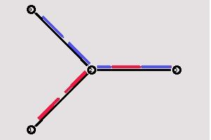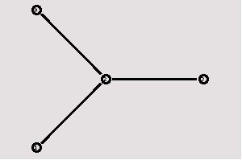
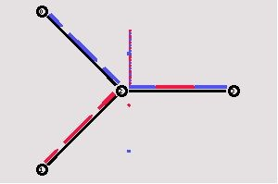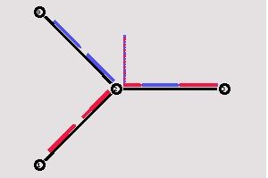
AIM: Wireless scenario and analysis using AWT and XGRAPH

CODE:
# simple-wireless.tcl
# A simple example for wireless simulation
# ======================================================================
# Define options
# ======================================================================
set val(chan) Channel/WirelessChannel ;# channel type
set val(prop) Propagation/TwoRayGround ;# radio-propagation model
set val(netif) Phy/WirelessPhy ;# network interface type
set val(mac) Mac/802_11 ;# MAC type
set val(ifq) Queue/DropTail/PriQueue ;# interface queue type
set val(ll) LL ;# link layer type
set val(ant) Antenna/OmniAntenna ;# antenna model
set val(ifqlen) 50 ;# max packet in ifq
set val(nn) 5 ;# number of mobilenodes
set val(rp) AODV ;# routing protocol
# ======================================================================
# Main Program
# ======================================================================
#
# Initialize Global Variables
#
set ns_ [new Simulator]
set tracefd [open simple.tr w]
$ns_ trace-all $tracefd
set namtr [open out1.nam w]
$ns_ namtrace-all-wireless $namtr 500 500
# set up topography object
set topo [new Topography]
$topo load_flatgrid 500 500
#
# Create God
#
create-god $val(nn)
#
# Create the specified number of mobilenodes [$val(nn)] and "attach" them
# to the channel.
# Here two nodes are created : node(0) and node(1)

# configure node
$ns_ node-config -adhocRouting $val(rp) \
-llType $val(ll) \
-macType $val(mac) \
-ifqType $val(ifq) \
-ifqLen $val(ifqlen) \
-antType $val(ant) \
-propType $val(prop) \
-phyType $val(netif) \
-channelType $val(chan) \
-topoInstance $topo \
-agentTrace OFF \
-routerTrace ON \
-macTrace OFF \
-movementTrace OFF
for {set i 0} {$i < $val(nn) } {incr i} {
set node_($i) [$ns_ node]
$node_($i) random-motion 0 ;# disable random motion
}
#
# Provide initial (X,Y, for now Z=0) co-ordinates for mobilenodes
#
$node_(0) set X_ 50.0
$node_(0) set Y_ 20.0
$node_(0) set Z_ 0.0
$node_(1) set X_ 390.0
$node_(1) set Y_ 385.0
$node_(1) set Z_ 0.0
$node_(2) set X_ 150.0
$node_(2) set Y_ 120.0
$node_(2) set Z_ 0.0
$node_(3) set X_ 250.0
$node_(3) set Y_ 220.0
$node_(3) set Z_ 0.0
$node_(4) set X_ 350.0
$node_(4) set Y_ 320.0
$node_(4) set Z_ 0.0
#
# Now produce some simple node movements
# Node_(1) starts to move towards node_(0)
#
$ns_ at 50.0 "$node_(1) setdest 25.0 20.0 15.0"
$ns_ at 10.0 "$node_(0) setdest 20.0 18.0 1.0"
$ns_ at 20.0 "$node_(2) setdest 20.0 18.0 1.0"
$ns_ at 30.0 "$node_(3) setdest 20.0 18.0 1.0"
$ns_ at 40.0 "$node_(4) setdest 20.0 18.0 1.0"
# Node_(1) then starts to move away from node_(0)
$ns_ at 100.0 "$node_(1) setdest 490.0 480.0 15.0"
# Setup traffic flow between nodes
# TCP connections between node_(0) and node_(1)
set tcp [new Agent/TCP]
$tcp set class_ 2
set sink [new Agent/TCPSink]
$ns_ attach-agent $node_(0) $tcp
$ns_ attach-agent $node_(1) $sink
$ns_ connect $tcp $sink
set ftp [new Application/FTP]
$ftp attach-agent $tcp
$ns_ at 10.0 "$ftp start"
#
# Tell nodes when the simulation ends
#
for {set i 0} {$i < $val(nn) } {incr i} {
$ns_ at 150.0 "$node_($i) reset";
}
$ns_ at 150.0 "stop"
$ns_ at 150.01 "puts \"NS EXITING...\" ; $ns_ halt"
proc stop {} {
global ns_ tracefd
$ns_ flush-trace
close $tracefd
}
puts "Starting Simulation..."
$ns_ run
OUTPUT:
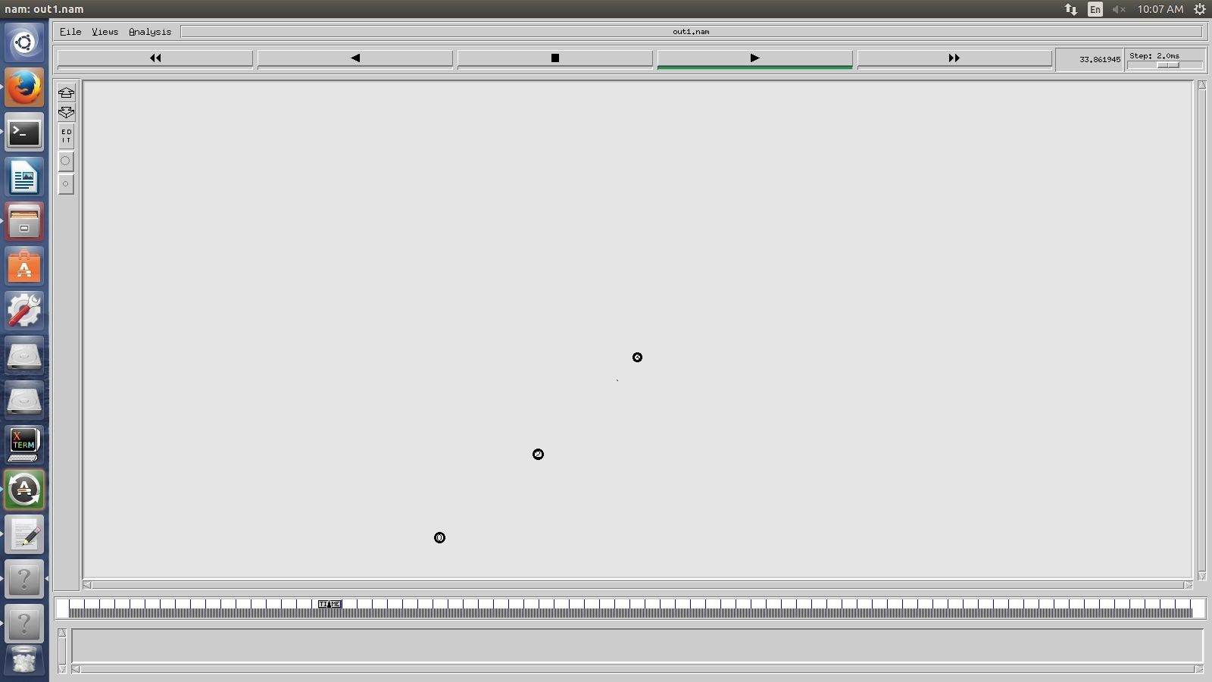
AIM: Mobile app in J2ME using wireless toolkit for simple calculator

CODE:
import javax.microedition.lcdui.*;
import javax.microedition.midlet.*;
import java.io.*;
public class scientific extends MIDlet implements CommandListener {
private Form form;
private Display display;
private TextField input1, input2;
private Command add, sub, mul, div, sin, cos, tan, log, e, sq;
private StringItem item;
public scientific() {
}
public void startApp() {
display = Display.getDisplay(this);
Form form = new Form("Calculator");
form.append("Hello everybody");
item = new StringItem("Result", "");
input1 = new TextField("First Number:", "", 30, TextField.NUMERIC);
input2 = new TextField("Second Number", "", 30, TextField.NUMERIC);
form.append(input1);
form.append(input2);
add = new Command("Addition", Command.OK, 1);
sub = new Command("Subtraction", Command.OK, 1);
mul = new Command("Multiplication", Command.OK, 1);
div = new Command("Division", Command.OK, 1);
sin = new Command("Sine", Command.OK, 1);
cos = new Command("Cosine", Command.OK, 1);
tan = new Command("Tangent", Command.OK, 1);
log = new Command("Logarithm", Command.OK, 1);
e = new Command("E", Command.OK, 1);
sq = new Command("SquareRoot", Command.OK, 1);
form.addCommand(add);
form.addCommand(sub);
form.addCommand(mul);
form.addCommand(div);
form.addCommand(sin);
form.addCommand(cos);
form.addCommand(tan);
form.addCommand(log);
form.addCommand(e);
form.addCommand(sq);
form.append(item);
form.setCommandListener(this);
display.setCurrent(form);
}
public void pauseApp() {}
public void destroyApp(boolean uncondn) {
notifyDestroyed();
}
private void calculate() {
int one = Integer.parseInt(input1.getString());
int two = Integer.parseInt(input2.getString());
int result = one + two;
item.setText(result + "");
}
private void calculate1() {
int one = Integer.parseInt(input1.getString());
int two = Integer.parseInt(input2.getString());
int result = one - two;
item.setText(result + "");
}
private void calculate2() {
int one = Integer.parseInt(input1.getString());
int two = Integer.parseInt(input2.getString());
int result = one * two;
item.setText(result + "");
}
private void calculate3() {
int one = Integer.parseInt(input1.getString());
int two = Integer.parseInt(input2.getString());
int result = one / two;
item.setText(result + "");
}
private void calculate4() {
int one = Integer.parseInt(input1.getString());
double result = Math.sin(one);
item.setText(result + "");
}
private void calculate5() {
int one = Integer.parseInt(input1.getString());
double result = Math.cos(one);
item.setText(result + "");
}
private void calculate6() {
int one = Integer.parseInt(input1.getString());
double result = Math.tan(one);
item.setText(result + "");
}
private static double pow(double base, int exp) {
if (exp == 0) return 1;
double res = base;
for (; exp > 1; --exp)
res *= base;
return res;
}
private void calculate7() {
int one = Integer.parseInt(input1.getString());
long l = Double.doubleToLongBits(one);
long exp = ((0x7ff0000000000000 L & l) >> 52) - 1023;
double man = (0x000fffffffffffff L & l) / (double) 0x10000000000000 L + 1.0;
double lnm = 0.0;
double a = (man - 1) / (man + 1);
for (int n = 1; n < 7; n += 2) {
lnm += pow(a, n) / n;
}
double result = 2 * lnm + exp * 0.69314718055994530941723212145818;
item.setText(result + "");
}
private void calculate8() {
int one = Integer.parseInt(input1.getString());
double result = pow(Math.E, one);
item.setText(result + "");
}
private void calculate9() {
int one = Integer.parseInt(input1.getString());
double result = Math.sqrt(one);
item.setText(result + "");
}
public void commandAction(Command c, Displayable d) {
String label = c.getLabel();
if (label.equals("Addition")) {
calculate();
} else if (label.equals("Subtraction")) {
calculate1();
} else if (label.equals("Multiplication")) {
calculate2();
form.append("The Answer is:");
} else if (label.equals("Division")) {
calculate3();
form.append("The Answer is:");
} else if (label.equals("Sine")) {
calculate4();
form.append("The Answer is:");
} else if (label.equals("Cosine")) {
calculate5();
form.append("The Answer is:");
} else if (label.equals("Tangent")) {
calculate6();
form.append("The Answer is:");
} else if (label.equals("Logarithm")) {
calculate7();
form.append("The Answer is:");
} else if (label.equals("E")) {
calculate8();
form.append("The Answer is:");
} else if (label.equals("SquareRoot")) {
calculate9();
form.append("The Answer is:");
}
}
}
OUTPUT:
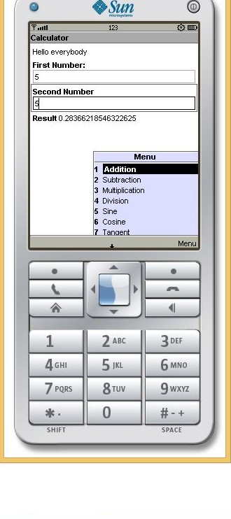
AIM: Mobile app in J2ME using wireless toolkit for client-server communication

CODE:
TCP Server:
import javax.microedition.midlet.*;
import javax.microedition.lcdui.*;
import java.io.*;
import javax.microedition.io.*;
public class sockserver extends MIDlet implements CommandListener,Runnable
{
Display display;
Form form;
Command button1,button2;
Thread thread1; // important
public sockserver()
{
display = Display.getDisplay(this);
form = new Form("");
button1 = new Command("startserver",Command.OK,1);
form.addCommand(button1);
form.setCommandListener(this);
System.out.println("constructor ok");
form.append("constructor ok\n");
thread1 = new Thread(this);
System.out.println("thread defined");
form.append("thread defined\n");
}
public void startApp()
{ display.setCurrent(form); }
public void pauseApp() {}
public void destroyApp(boolean b) {}
public void commandAction(Command c, Displayable d)
{
if(c==button1)
{
thread1.start();
form.append("thread started\n");
}
}
public void run()
{
try
{
ServerSocketConnection server = (ServerSocketConnection)
Connector.open("socket://:9000");
form.append("server ready\n");
while(true)
{
StreamConnection connection =server.acceptAndOpen();
form.append("client connected\n");
InputStream ins = (InputStream)connection.openInputStream();
DataInputStream dis = new DataInputStream(ins);
System.out.println("ready to get data\n");
String r = dis.readUTF(); form.append(r+"\n"); form.append("data received\n");
OutputStream os = (OutputStream)connection.openOutputStream(); DataOutputStream dos =new DataOutputStream(os); dos.writeUTF("data received!"+"\n"+"thank you"); form.append("\n"+"ack sent");
}
}
catch (Exception e1)
{ form.append(""+e1);}
}
}
TCP Client:
import javax.microedition.midlet.*;
import javax.microedition.lcdui.*;
import java.io.*;
import javax.microedition.io.*;
public class sockclient extends MIDlet implements CommandListener,Runnable
{
Display display;
Form form1;
TextField text1;
Command button1;
Thread thread1;
public sockclient()
{
display = Display.getDisplay(this);
form1 = new Form("");
button1 = new Command("send",Command.OK,1);
form1.addCommand(button1);
form1.setCommandListener(this);
text1 = new TextField("","",60,0);
form1.append(text1);
form1.append("client ok\n");
thread1 = new Thread(this);
form1.append("thread1 ok\n");
}
public void startApp()
{ display.setCurrent(form1); }
public void pauseApp() {}
public void destroyApp(boolean b) {}
public void commandAction(Command c, Displayable d)
{
if(c==button1)
{
form1.append("trying to get server\n");
thread1.start();
}
}
public void run()
{
try
{
SocketConnection connection = (SocketConnection) Connector.open("socket://localhost:9000");
form1.append("connected to server\n");
OutputStream os = (OutputStream)connection.openOutputStream();
DataOutputStream dos = new DataOutputStream(os);
form1.append("sending line ready\n");
String s = text1.getString();
dos.writeUTF(s);
form1.append("message sent to server\n");
form1.append(s);
InputStream ins = connection.openInputStream();
DataInputStream dis =new DataInputStream(ins);
String r = dis.readUTF();
form1.append(r);
}
catch (IOException e1)
{System.out.println(""+e1);} } }

OUTPUT:
Build & Run Both Client and Server.
Start the Server, then type any text on Client. Click Send.
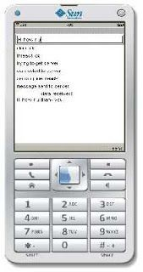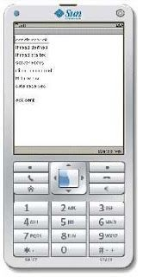
AIM: Android user login application

CODE:
activity_user.xml
<RelativeLayout xmlns:android="http://schemas.android.com/apk/res/android"
xmlns:tools="http://schemas.android.com/tools" android:layout_width="match_parent"
android:layout_height="match_parent" android:paddingLeft="@dimen/activity_horizontal_margin"
android:paddingRight="@dimen/activity_horizontal_margin"
android:paddingTop="@dimen/activity_vertical_margin"
android:paddingBottom="@dimen/activity_vertical_margin"
tools:context="com.djsce.student.simpleloginapp.UserActivity">
<TextView android:layout_width="wrap_content" android:layout_height="wrap_content"
android:textAppearance="?android:attr/textAppearanceLarge"
android:text="@string/screen_page_text" android:id="@+id/textView"
android:layout_centerVertical="true" android:layout_centerHorizontal="true" />
</RelativeLayout>
AndroidManifest.xml
<?xml version="1.0" encoding="utf-8"?>
<manifest xmlns:android="http://schemas.android.com/apk/res/android"
package="com.djsce.student.simpleloginapp" >
<application android:allowBackup="true" android:icon="@mipmap/ic_launcher"
android:label="@string/app_name" android:theme="@style/AppTheme" >
<activity android:name=".LoginActivity" android:label="@string/app_name" >
<intent-filter>
<action android:name="android.intent.action.MAIN" />
<category android:name="android.intent.category.LAUNCHER" />
</intent-filter>
</activity>
<activity android:name=".UserActivity" android:label="@string/title_activity_user" >
<intent-filter>
<action android:name="com.djsce.student.simpleloginapp.UserActivity" />
<category android:name="android.intent.category.default" />
</intent-filter>
</activity>
</application>
</manifest>
strings.xml
<resources>
<string name="app_name">SimpleLoginApp</string>
<string name="hello_world">Hello world!</string>
<string name="action_settings">Settings</string>
<string name="title_activity_user">UserActivity</string>
<string name="login_text">Login Page</string>
<string name="username_text">User Name</string>
<string name="password_text">Password</string>
<string name="attempt_text">Attempt</string>
<string name="button_login_text">Login</string>
<string name="screen_page_text">Welcome to the second page</string>
</resources>
login.java
package com.djsce.student.loginapp;

import android.content.Intent;
import android.support.v7.app.AppCompatActivity;
import android.os.Bundle; import android.view.Menu; import android.view.MenuItem; import android.view.View; import android.widget.Button; import android.widget.EditText;
import android.widget.TextView;
import android.widget.Toast;
public class Login extends AppCompatActivity {
private static EditText username;
private static EditText password;
private static TextView attempt;
private static Button login_button;
int attempt_counter=5;
@Override
protected void onCreate(Bundle savedInstanceState) {
super.onCreate(savedInstanceState);
setContentView(R.layout.activity_login);
LoginButton();
}
public void LoginButton(){
username = (EditText)findViewById(R.id.editText_user);
password = (EditText)findViewById(R.id.editText_password);
attempt = (TextView)findViewById(R.id.textView_attempt);
login_button = (Button)findViewById(R.id.button_login);
attempt.setText(Integer.toString(attempt_counter));
login_button.setOnClickListener(
new View.OnClickListener() {
@Override
public void onClick(View v) {
if (username.getText().toString().equals("user") &amp;amp;amp;&amp;amp;amp;
password.getText().toString().equals("pass")){
Toast.makeText(Login.this,"Username and password is correct",
Toast.LENGTH_SHORT).show();
Intent intent = new Intent("com.djsce.student.loginapp.User");
startActivity(intent);
}
else {
Toast.makeText(Login.this,"Username and password is NOT correct",
Toast.LENGTH_SHORT).show();
attempt_counter--;
attempt.setText(Integer.toString(attempt_counter));
if(attempt_counter==0)
login_button.setEnabled(false);
}
}
}
);
}
@Override
public boolean onCreateOptionsMenu(Menu menu) {
// Inflate the menu; this adds items to the action bar if it is present.
getMenuInflater().inflate(R.menu.menu_login, menu);
return true;
}
@Override
public boolean onOptionsItemSelected(MenuItem item) {
// Handle action bar item clicks here. The action bar will
// automatically handle clicks on the Home/Up button, so long
// as you specify a parent activity in AndroidManifest.xml.
int id = item.getItemId();
//noinspection SimplifiableIfStatement
if (id == R.id.action_settings) {
return true;
}
return super.onOptionsItemSelected(item);
}
}
OUTPUT:
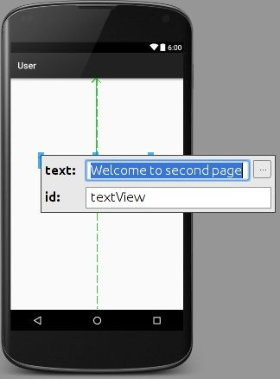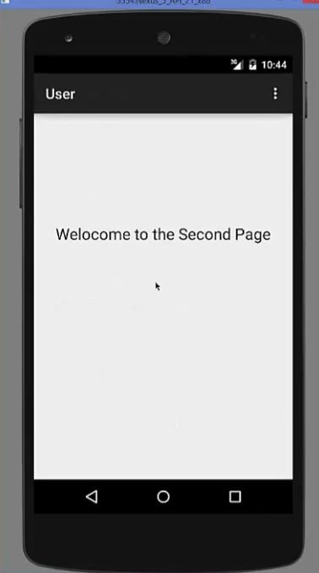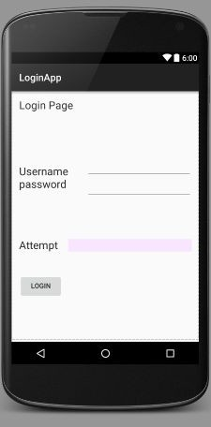
AIM: Android GPS tracking application

CODE: MainActivity.java
package com.example.djsce.student.myapplication;
import android.Manifest;
import android.app.Activity;
import android.os.Bundle;
import android.support.v4.app.ActivityCompat;
import android.test.mock.MockPackageManager;
import android.view.View;
import android.widget.Button;
import android.widget.Toast;
public class MainActivity extends Activity {
Button btnShowLocation;
private static final int REQUEST_CODE_PERMISSION = 2;
String mPermission = Manifest.permission.ACCESS_FINE_LOCATION;
// GPSTracker class
GPSTracker gps;
@Override
public void onCreate(Bundle savedInstanceState) {
super.onCreate(savedInstanceState);
setContentView(R.layout.activity_main);
try {
if (ActivityCompat.checkSelfPermission(this, mPermission)
!= MockPackageManager.PERMISSION_GRANTED) {
ActivityCompat.requestPermissions(this, new String[]{mPermission},
REQUEST_CODE_PERMISSION);
// If any permission above not allowed by user, this condition will
execute every time, else your else part will work
}
} catch (Exception e) {
e.printStackTrace();
}
btnShowLocation = (Button) findViewById(R.id.button);
// show location button click event
btnShowLocation.setOnClickListener(new View.OnClickListener() {
@Override
public void onClick(View arg0) {
// create class object
gps = new GPSTracker(MainActivity.this);
// check if GPS enabled
if(gps.canGetLocation()){
double latitude = gps.getLatitude();
double longitude = gps.getLongitude();
// \n is for new line
Toast.makeText(getApplicationContext(), "Your Location is - \nLat: "
+ latitude + "\nLong: " + longitude, Toast.LENGTH_LONG).show();
}else{
// can't get location
// GPS or Network is not enabled
// Ask user to enable GPS/network in settings
gps.showSettingsAlert();
}
}
});
}
}

GPSTracker.java

package com.example.djsce.student.myapplication;
import android.app.AlertDialog;
import android.app.Service;
import android.content.Context;
import android.content.DialogInterface;
import android.content.Intent;
import android.location.Location;
import android.location.LocationListener;
import android.location.LocationManager;
import android.os.Bundle;
import android.os.IBinder;
import android.provider.Settings;
import android.util.Log;
public class GPSTracker extends Service implements LocationListener {
private final Context mContext;
// flag for GPS status
boolean isGPSEnabled = false;
// flag for network status
boolean isNetworkEnabled = false;
// flag for GPS status
boolean canGetLocation = false;
Location location; // location
double latitude; // latitude
double longitude; // longitude
// The minimum distance to change Updates in meters
private static final long MIN_DISTANCE_CHANGE_FOR_UPDATES = 10; // 10 meters
// The minimum time between updates in milliseconds
private static final long MIN_TIME_BW_UPDATES = 1000 * 60 * 1; // 1 minute
// Declaring a Location Manager
protected LocationManager locationManager;
public GPSTracker(Context context) {
this.mContext = context;
getLocation();
}
public Location getLocation() {
try {
locationManager = (LocationManager) mContext.getSystemService(LOCATION_SERVICE);
// getting GPS status
isGPSEnabled = locationManager.isProviderEnabled(LocationManager.GPS_PROVIDER);
// getting network status
isNetworkEnabled = locationManager
.isProviderEnabled(LocationManager.NETWORK_PROVIDER);
if (!isGPSEnabled && !isNetworkEnabled) {
// no network provider is enabled
} else {
this.canGetLocation = true;
// First get location from Network Provider
if (isNetworkEnabled) {
locationManager.requestLocationUpdates(
LocationManager.NETWORK_PROVIDER,
MIN_TIME_BW_UPDATES,
MIN_DISTANCE_CHANGE_FOR_UPDATES, this)
Log.d("Network", "Network");
if (locationManager != null) {
location = locationManager
.getLastKnownLocation(LocationManager.NETWORK_PROVIDER);
if (location != null) {
latitude = location.getLatitude();
longitude = location.getLongitude();
}
}
}
// if GPS Enabled get lat/long using GPS Services if (isGPSEnabled) {
if (location == null) {
locationManager.requestLocationUpdates(
LocationManager.GPS_PROVIDER,
MIN_TIME_BW_UPDATES,
MIN_DISTANCE_CHANGE_FOR_UPDATES, this);

Log.d("GPS Enabled", "GPS Enabled");
if (locationManager != null) {
location = locationManager
.getLastKnownLocation(LocationManager.GPS_PROVIDER);
if (location != null) {
latitude = location.getLatitude();
longitude = location.getLongitude();
}
}
}
}
}
} catch (Exception e) {
e.printStackTrace();
}
return location;
}
/**
* Stop using GPS listener
* Calling this function will stop using GPS in your app
* */
public void stopUsingGPS(){
if(locationManager != null){
locationManager.removeUpdates(GPSTracker.this);
}
}
/**
* Function to get latitude
* */
public double getLatitude(){
if(location != null){
latitude = location.getLatitude();
}
// return latitude return latitude;
}
/**
* Function to get longitude
* */
public double getLongitude(){
if(location != null){
longitude = location.getLongitude();
}
// return longitude
return longitude;
}
/**
* Function to check GPS/wifi enabled
* @return boolean
* */
public boolean canGetLocation() {
return this.canGetLocation;
}

/**
* Function to show settings alert dialog
* On pressing Settings button will lauch Settings Options
* */
public void showSettingsAlert(){
AlertDialog.Builder alertDialog = new AlertDialog.Builder(mContext);
// Setting Dialog Title
alertDialog.setTitle("GPS is settings");
// Setting Dialog Message
alertDialog.setMessage("GPS is not enabled. Do you want to go to settings menu?");
// On pressing Settings button
alertDialog.setPositiveButton("Settings", new DialogInterface.OnClickListener() {
public void onClick(DialogInterface dialog,int which) {
Intent intent = new Intent(Settings.ACTION_LOCATION_SOURCE_SETTINGS);
mContext.startActivity(intent);
}
});
// on pressing cancel button
alertDialog.setNegativeButton("Cancel", new DialogInterface.OnClickListener() {
public void onClick(DialogInterface dialog, int which) {
dialog.cancel();
}
});
// Showing Alert Message
alertDialog.show();
}
@Override
public void onLocationChanged(Location location) {
}
@Override
public void onProviderDisabled(String provider) {
}
@Override
public void onProviderEnabled(String provider) {
}
@Override
public void onStatusChanged(String provider, int status, Bundle extras) {
}
@Override
public IBinder onBind(Intent arg0) {
return null;
}
}

res/layout/activity_main.xml

<?xml version = "1.0" encoding = "utf-8"?>
<LinearLayout xmlns:android = "http://schemas.android.com/apk/res/android"
android:layout_width = "fill_parent"
android:layout_height = "fill_parent"
android:orientation = "vertical" >
<Button
android:id = "@+id/button"
android:layout_width = "fill_parent"
android:layout_height = "wrap_content"
android:text = "getlocation"/>
</LinearLayout>

res/values/strings.xml

<?xml version = "1.0" encoding = "utf-8"?>
<resources>
<string name = "app_name">djsce.student</string>
</resources>

AndroidManifest.xml

<?xml version = "1.0" encoding = "utf-8"?>
<manifest xmlns:android = "http://schemas.android.com/apk/res/android"
package = "com.example.djsce.student.myapplication">
<uses-permission android:name = "android.permission.ACCESS_FINE_LOCATION" />
<uses-permission android:name = "android.permission.INTERNET" />
<application
android:allowBackup = "true"
android:icon = "@mipmap/ic_launcher"
android:label = "@string/app_name"
android:supportsRtl = "true"
android:theme = "@style/AppTheme">
<activity android:name = ".MainActivity">
<intent-filter>
<action android:name = "android.intent.action.MAIN" />
<category android:name = "android.intent.category.LAUNCHER" />
</intent-filter>
</activity>
</application
</manifest>
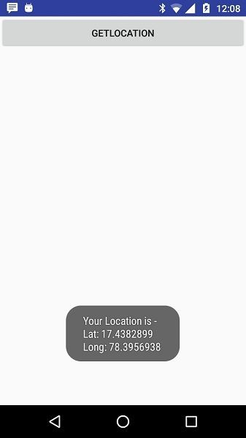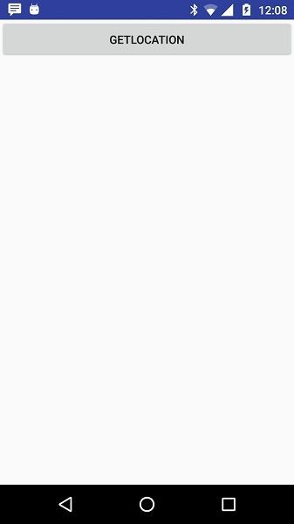OUTPUT:

